[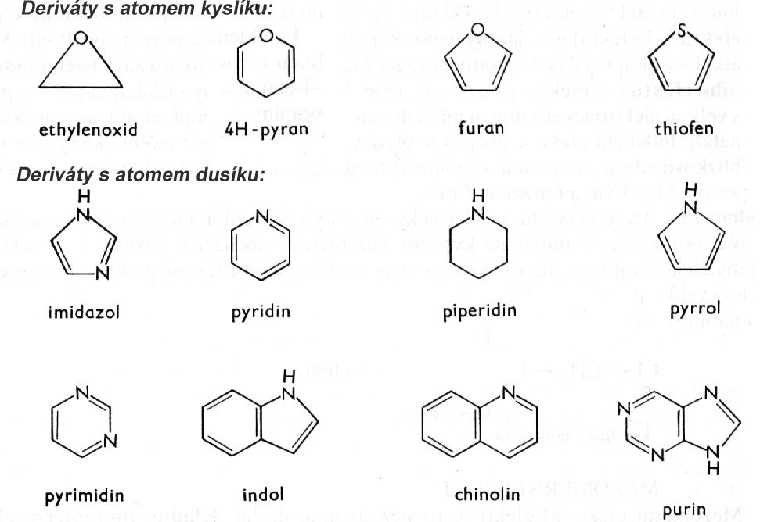](https://www.google.cz/url?sa=i&rct=j&q=&esrc=s&source=images&cd=&cad=rja&uact=8&ved=0ahUKEwiKp_fErL7WAhUBXBoKHYztDdIQjRwIBw&url=http%3A%2F%2Ffld.czu.cz%2Fvyzkum%2Fnauka_o_lp%2Fzal_13_12_2012%2Fchemie%2Fchemie.html&psig=AFQjCNEYZnWh2VNPGnqrvqZSI_DUxnK8Sg&ust=1506360560798213)

[](https://www.google.cz/url?sa=i&rct=j&q=&esrc=s&source=images&cd=&cad=rja&uact=8&ved=0ahUKEwiKp_fErL7WAhUBXBoKHYztDdIQjRwIBw&url=http%3A%2F%2Ffld.czu.cz%2Fvyzkum%2Fnauka_o_lp%2Fzal_13_12_2012%2Fchemie%2Fchemie.html&psig=AFQjCNEYZnWh2VNPGnqrvqZSI_DUxnK8Sg&ust=1506360560798213)